**Section 3 – For each entity, define the low level design:** This section provides the in depth detail of the object’s low level design, usage, ER diagram with model and interpretation of these objects.

**Usage**

This project consists of three objects, which are Scrapper, Database and GUI. The first object functions as a PDF convertor, which converts a PDF document to the appropriate format then it loads into SQL Database using JDBC. JDBC is the Java Soft determination of a standard application-programming interface (API) that permits Java projects to get to database administration frameworks. The JDBC API comprises of an arrangement of interfaces and classes written in the Java programming dialect. The second object is the Database, which takes the queries from the user and searches for the appropriate request and sends it back to GUI. The Database is implemented using MYSQL, which is a program used to write the SQL Database. For example, the question "What classes does Dr. Daugherity teach?" will be converted into SELECT classes FROM howdy WHERE instructor = ‘daugherty’. The third object is the GUI, which takes the search input of the user and send it to the Database for search. GUI is implemented using the JavaFX, which is a product stage for making and conveying desktop applications, and additionally rich web applications (RIAs) that can keep running over a wide assortment of gadgets. JavaFX is expected to supplant Swing as the standard GUI library for Java SE, yet both will be incorporated for a long time to come.

**Model**

The figures below describes the design of the whole howdy class search project.

1. **ER Diagram of Scrapper**

This diagram shows the design of the Scrapper.

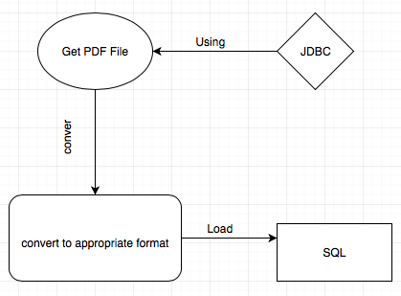

1. **ER Diagram of Database**

This diagram shows the design of the Database

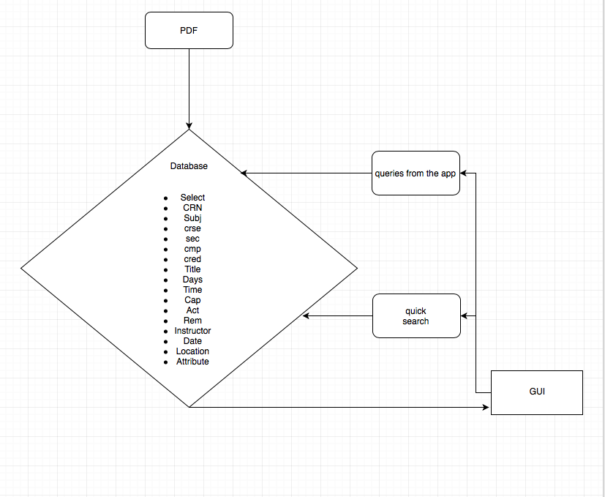

1. **ER Diagram of GUI**

This diagram shows the design of the GUI

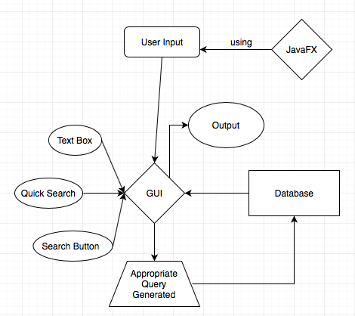

**Interaction**

Interaction basically shows how three objects are communicated with each other.

